GLOBAL AI DYNAMICS: MAPPING THE AI UTILIZATION ACROSS NATIONS

Submitted for

DATA VISULIZATION AND DASHBOARD

Submitted by:
(E23MCAG0004) HENSIKA BISHNOI
(E23MCAG0049) EEVA MEHRA
(E23MCAG0095) SAANVI RUSIA

Submitted to-
Dr. Nitin Arvind Shelke

July-Dec 2023
SCHOOL OF COMPUTER SCIENCE AND ENGINEERING


INDEX

Sr No
Content | Page No
1. | Abstract | 4
2. | Introduction | 4
3. | Literature Review | 5
4. | Software Used | 6
5. | Methodology | 7
6. | Experimental Results | 8
7. | Conclusion | 14
8. | References | 14

LIST OF FIGURES

Figure No. | Title | Page No.
5.1 | Methodology Flowchart | 7
6.1 | Measures of AI Indicators | 9
6.2 | Bar Plot | 10
6.3 | AI Talent | 11
6.4 | AI Infrastructure | 11
6.5 | AI across the Globe | 12
6.6 | AI Dashboard | 13

- ABSTRACT
This research project delves into the evolutionary trajectory of artificial intelligence (AI) adoption across diverse countries spanning several decades. In an era where technology is integral to global development, understanding the nuanced dimensions of AI utilization is crucial for insights into societal, economic, and technological transformations. The study employs a comprehensive approach, analyzing historical contexts, policy frameworks, and technological infrastructures that have shaped AI deployment in different regions. Moving beyond quantitative metrics, our analysis focuses on the nuanced impact of AI in sectors such as healthcare, education, industry, and governance. Utilizing a comparative lens, the project elucidates the factors influencing the pace and depth of AI integration in nations with varying socio-economic backgrounds.
- INTRODUCTION
Artificial Intelligence is a multifaceted field of computer science that endeavors to create intelligent agents capable of mimicking human-like cognitive functions. It encompasses a spectrum of techniques and methodologies designed to equip machines with the ability to learn, reason, and make decisions. The fundamental goal of AI is to replicate human intelligence, enabling machines to interpret data, adapt to changing circumstances, and perform tasks that traditionally required human intelligence.
AI operates through various subfields, each addressing specific aspects of intelligent behavior. Machine Learning (ML) is a prominent subset of AI, focusing on the development of algorithms that enable systems to learn and improve from experience. Natural Language Processing (NLP) facilitates machine understanding and interpretation of human language, while Computer Vision empowers machines to interpret and comprehend visual information.
AI applications are pervasive in modern society, influencing industries such as healthcare, finance, education, and beyond. From recommendation systems and autonomous vehicles to virtual assistants and advanced robotics, AI is becoming increasingly embedded in everyday life. As AI technologies continue to advance, ethical considerations, transparency, and societal impact become integral aspects of the ongoing discourse surrounding the responsible development and deployment of artificial intelligence.
Dataset Description: The data used in this project was carefully analyzed and then chosen for guaranteed accurate visualization. The “AI Global Index” pioneers a comprehensive evaluation of 62 countries, gauging their commitment to artificial intelligence through seven indicators. These include AI Implementation factors like Talent, Infrastructure, and Operating Environment, Innovation factors such as Research and Development, and Investment factors like Government Strategy and Commercial initiatives. This index offers a succinct yet thorough analysis, providing valuable insights into each nation’s role in advancing AI on the global stage.

- LITERATURE REVIEW
Over the past few decades, artificial intelligence has emerged as a transformative force across various industries, revolutionizing sectors like healthcare and finance. Notably, generative AI has gained prominence for its capacity to produce innovative outputs such as images, videos, and music. Its application spans diverse fields, including technology, banking, and media, indicating a paradigm shift in content creation [1]. As AI becomes increasingly integrated into society, developers and implementers stand to benefit substantially [2]. Businesses leverage AI for enhanced analytic processing, while city officials employ it for tasks like traffic monitoring and smart energy metering [3]. However, the global development of AI presents challenges, with the risk of a fragmented governance landscape and a potential drop to the bottom in regulatory standards.
The competition among countries to attract AI industries through development incentives may lead to insufficient regulatory oversight, risky biased systems and societal threats [4]. The social impact of AI varies across geographical settings, influencing perceptions and exacerbating social inequalities; however, low- and middle-income countries may be more susceptible to negative social effects while benefiting less from the technology's gains [5]. Moreover, the widespread deployment of AI surveillance tools, including smart city platforms and facial recognition systems, raises concerns about privacy and human rights violations in numerous countries. Despite the challenges, the lack of a clear definition of AI complicates the establishment of measurable output indicators, emphasizing the need for a nuanced understanding of national AI strategies as communication tools that foster strategic engagement with this transformative technology within government [6].

Table 1. Classification of Literature Review

Reference No. | Dataset Used | Description
[1] | AI Index Report 2020 | Analyses generative AI on a wide scale and iterates how the race to achieve a greater version of AI presents serious consequences
[2] | ImageNet and OpenImages | Presents measures required to ensure AI development is leveled and causes no inequality
[3] | AI in Research 2022 | Reframes standards and lays foundation for consensus-based rules
[4] | AI Global Surveillance (AIGS) Index | Discusses the importance of AI in surveillance and how government policies are essential for AI usage regulation
[5] | Emerging Technologies | Explains how AI has varying effects on different person groups, focusing on class and income disparities
[6] | Sector AI ETFs | Emphasizes the up-and-coming AI technologies and provides ideas for development

- SOFTWARE USED
The workflow involves using a variety of software applications skillfully in order to make data administration, analysis, and presentation go more smoothly. Excel is the starting point for data loading, functioning as the primary source of the relevant data. The creation of dynamic and eye-catching dashboards is then accomplished with the use of Power BI, an effective business intelligence solution. Parallel to this, Jupyter, an interactive computing environment, works well with Python, a flexible programming language.

- METHODOLOGY
The objective of the data visualization methodology is to derive useful insights from raw data through a systematic series of operations. The procedure begins with data collection and continues with a meticulous cleaning stage that addresses missing values and removes duplicates in order to ensure data integrity. After then, the structure of the data is ascertained by carefully examining it. The next steps involve gathering and arranging reports, pinpointing and highlighting patterns using various statistical and probability measures, and determining trends.
One of the most important parts of the process is using graphical representation tools, like histograms, pie charts, bar graphs, and many others. These visual elements are a crucial factor in transforming complex, sizable data sets to easily comprehensible representations. These patterns further provide pertinent insights that contribute to the better understanding of vast, raw information.
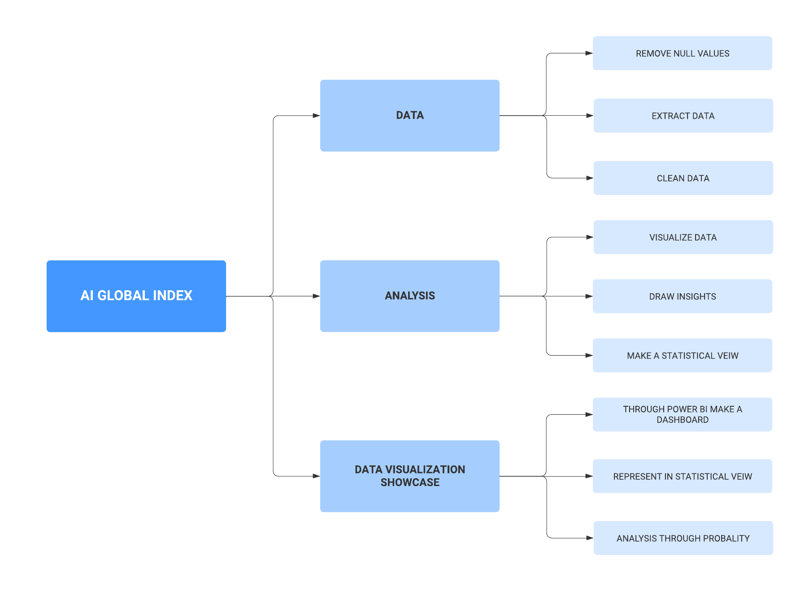
Fig 5.1 Methodology Flowchart
This approach of flowcharts in Fig 5.1 acts as a road map, taking the user step-by-step through the process of turning unprocessed data into informative visuals. To provide a comprehensive and well-rounded approach to data analysis and visualization, each stage builds upon the one before it.
Data Preprocessing: A format for the 'Country' column that was to be used for temporal analysis needed to be created by loading and then formatting the dataset. The various attributes of the dataset were compared keeping a common element at this stage, which was crucial for enabling effective trend analysis.
For our analysis to be as accurate as possible, we employed data cleaning techniques. In order to prevent any outliers from affecting the results, inconsistent data, and missing values from the dataset had to be addressed.
Normalization/Standardization: We then examined numerical variables and wherever necessary, they were normalized or standardized to level them in accordance with a common factor, ensuring that no single variable dominated the analysis due to its scale.
Exploratory Data Analysis (EDA): Descriptive statistics, such as mean, median, and standard deviation, were calculated for numerical variables. This provided an overview of the central tendencies and variability within the dataset, aiding in the identification of potential inconsistencies.
Visualization: Various plots were employed for EDA. Bar plots were used to illustrate trends in al index model over time. Scatter plots showcased the relationship between the number of country and junctions, providing meaningful insights into spatial patterns.

- EXPERIMENTAL RESULTS
The Global AI Index is the first of its kind to compare countries based on the amount of money they invest, how innovative they are, and how they use AI. The variables of the set of AI Implementation indicators, which reflects the application of artificial intelligence by experts in many sectors, such as corporations, governments, and communities include Talent, Infrastructure, and Operating Environment. The availability of qualified professionals to provide artificial intelligence solutions is the main emphasis of the Talent indicator. Infrastructure metrics emphasize dependability and scope of the infrastructure for access, from supercomputers to energy and the internet. The public's perception of artificial intelligence and the regulatory environment are the main areas of attention for the Operating Environment indicator.
The Innovation set of indicators includes Research and Development as factors. These factors represent technological and methodological advancements and indicate the potential for artificial intelligence to advance and become more sophisticated. The Research indicator looks at the number of publications and citations in reputable academic journals, focusing on the scope of specialized research and researchers. The development of core platforms and algorithms, which are the foundation of creative artificial intelligence initiatives, is the emphasis of the Development indicator.
The Investment group of indicators comprises Government Strategy and Commercial elements that represent financial and procedural commitments to artificial intelligence. The Government Strategy indicator pertains to the level of dedication exhibited by the national government (see Fig. 6.1).
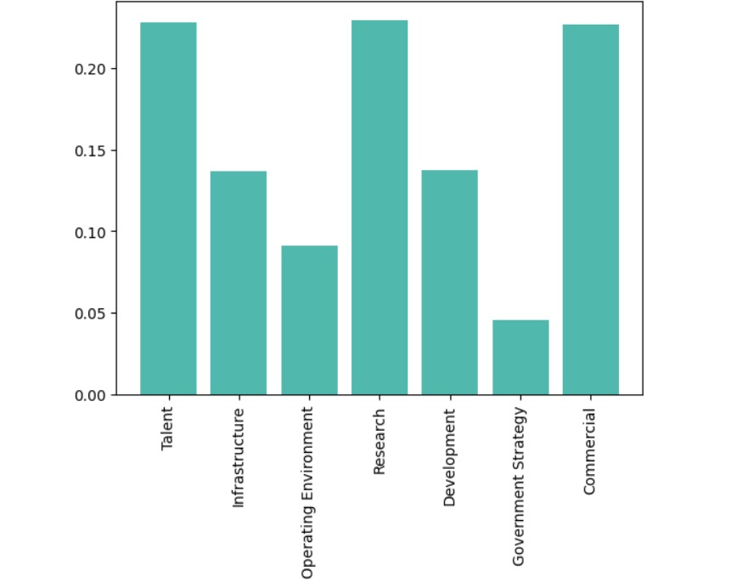
Fig 6.1 Measures of AI Indicators

In Fig 6.2, the horizontal axis represents different clusters, while the vertical axis indicates the number of countries falling within each cluster. The clusters are visually differentiated, and the bars corresponding to each cluster display the respective count of countries. The intention is to provide a clear representation of how ‘Waking Up’ quantities compared to other clusters, allowing for quick insights into the distribution of countries based on this parameter. This visualization aims to facilitate a comparative analysis, enabling viewers to visualize the significance of various clusters, thereby contributing to a better understanding of the overall dataset. The dataset consists of the Global AI Index itself as well as other generic data about the 62 nations (such as location, income category, and political regime), the Index is influenced by seven other factors.

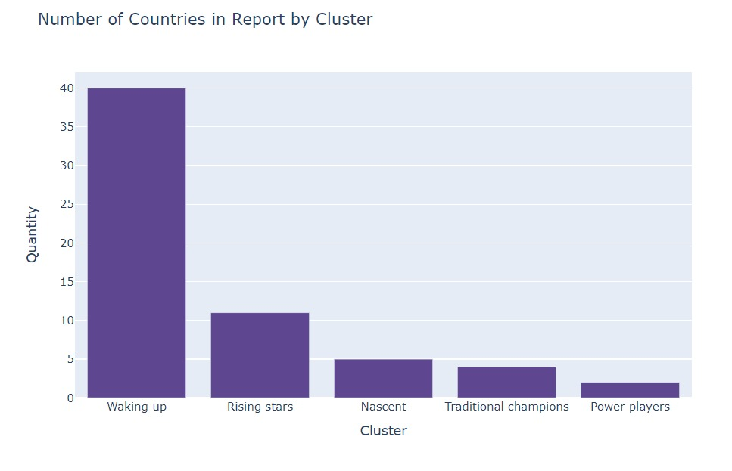
Fig 6.2 Bar Plot

AI Talent: Fig 6.3 show that the United States leads in AI talent, followed by India, Great Britain, Singapore, and Israel. However, most countries have low scores in this aspect.
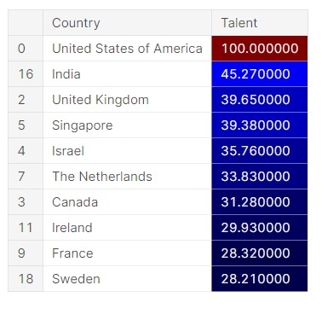
Fig 6.3 AI Talent
AI Infrastructure: China tops the technological infrastructure for AI shown in Fig 6.4, closely followed by Hong Kong, Luxemburg, the United States, and Ireland. About 80% of countries have good infrastructure for AI.
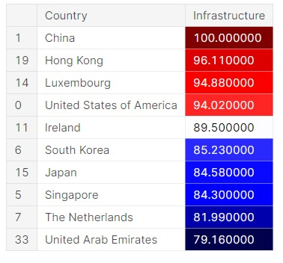
Fig 6.4 AI Infrastructure
Additionally, Saudi Arabia is viewed as the most AI-friendly society, followed by Poland, Mexico, Slovenia, and Canada. Generally, optimism about AI prevails globally, with 85% of countries having a favorable operating environment.
Top 5 AI Implementation: According to Tortoise Media's methodology, the top countries in AI Implementation are the United States, The Netherlands, Canada, China, and Great Britain. Only 35% of countries have a high implementation score. Overall, the United States excels in AI talent, while China leads in AI infrastructure. Saudi Arabia is noted for having the most AI-friendly society. However, global AI implementation remains relatively low across countries (see Fig 6.5).
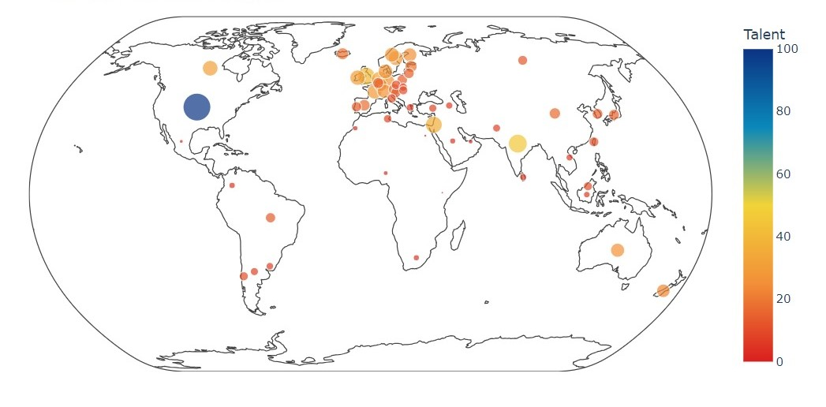
Fig 6.5 AI across the Globe
On a generic note, there are two Power Players are on the map - the United States and China; however, China is almost 40% weaker than the USA. The following two countries, the United Kingdom and Canada are Traditional Champions (according to Tortoise Media’s classification). However, Germany and France, the other two Traditional Champions, stand in the next four positions after Israel, Singapore, South Korea, and the Netherlands (classified as Rising Stars). The other Rising Stars are Australia, Ireland, Finland, Denmark, Japan, and Spain. All other countries except Sri Lanka, Egypt, Kenya, Nigeria, and Pakistan are the Waking Up players; the remaining are Nascent Players.
Utilizing Power BI, we constructed a dynamic dashboard (see Fig 6.6) capturing diverse facets of AI adoption across countries. After meticulous data collection and cleaning, the dashboard employs various visualizations, such as pie charts and bar graphs, to represent factors like technology prevalence, R&D investments, and workforce composition. Its interactive nature allows users to explore specific details for each country, fostering a nuanced understanding of global AI landscapes. This user-friendly tool facilitates informed decision-making, enabling stakeholders to navigate and comprehend the complex dynamics of AI utilization effortlessly.

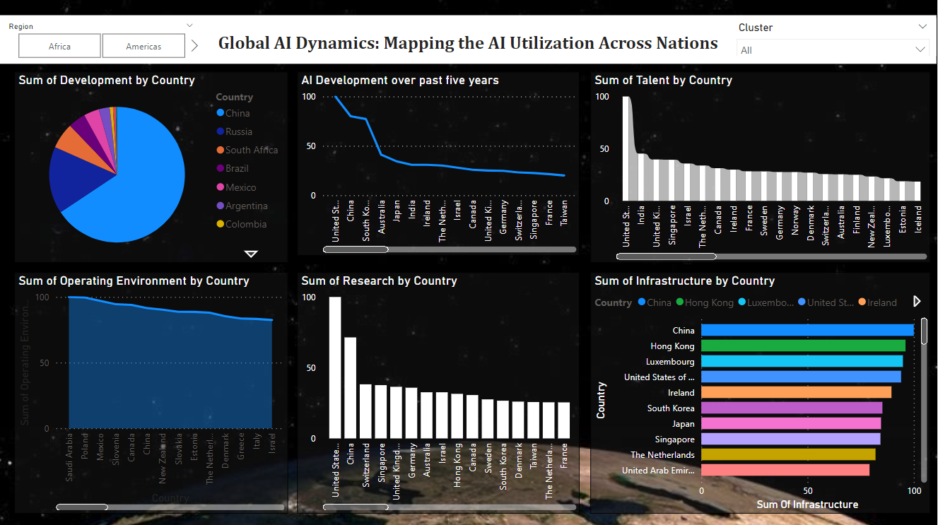
Fig 6.6 AI Dashboard

- CONCLUSION
Regarding the future, it is anticipated that AI will keep expanding on a worldwide scale. AI has seen a sharp rise in funding, research, and development in recent years, and many nations now view it as a top strategic priority. Healthcare, banking, transportation, and education are just a few of the industries that artificial intelligence has already shown it can revolutionize. The potential uses of artificial intelligence are many and constantly growing due to the continuous improvements in AI technologies like deep learning, reinforcement learning, and natural language processing, among others. As a result, it's possible that AI will develop further and affect many facets of our life in the future.

- REFERENCES
[1] Chiang, I. (2023). Authored By: Ian Chiang MIT Sloan School of ManagementMay 10 th.
[2] Chan, A., Okolo, C. T., Terner, Z., & Wang, A. (2021). The Limits of Global Inclusion in AI Development. http://arxiv.org/abs/2102.01265
[3] Cihon, P., Leung, J., Ding, J., Garfinkel, B., Dafoe, A., Maas, M., Zwetsloot, R., Hagebölling, D., Carey, R., Zhang, B., Fischer, S.-C., & Shevlane, T. (2019). Standards for AI Governance: International Standards to Enable Global Coordination in AI Research & Development. https://arxiv.org/pdf/1802.07228.pdf
[4] Feldstein, S. (2019). The Global Expansion of AI Surveillance.
[5] Hagerty, A., & Rubinov, I. (n.d.). Global AI Ethics: A Review of the Social Impacts and Ethical Implications of Artificial Intelligence.
[6] Heumann, S., & Zahn, N. (2018). Benchmarking National AI Strategies Why and how indicators and monitoring can support agile implementation. https://www.bundesfinanzministerium.de/Content/DE/Downloads/Digitalisierung/2018-

